 **AMERICAN INTERNATIONAL UNIVERSITY- BANGLADESH**

**PROJECT**

**Section: I**

**INTRODUCTION TO DATABASE**

**Submitted to:**

**Rezwan Ahmed**

**Department of CS**

**AMERICAN INTERNATIONAL UNIVERSITY- BANGLADESH**

**Submitted By:**

1. **NAME: ABDULLA AL IMRAN ID: 20-43271-1**
2. **NAME: SADMAN SHAKIB ID: 20-42211-1**
3. **NAME: HIMEL SAHADAT ID: 20-43272-1**
4. **NAME: SULTANA JUTHI ID: 20-43281-1**

**DESCRIPTION:** A coffee shop has always been more than a place to have a beverage. It is a place to socialize, ideate, have fun and meet new people. As Starbucks puts it, it’s the third place, a home away from home or office. Also, due to the competitive and busy lifestyle that people lead today, a coffee house near their work or home has become a major point of relaxation Coffee-Shop-Management-system is general software developed particularly for the Coffeeshop transaction. This is a desktop application. This software collects the details of Products, Costs, Admin & Workers information and their transaction. This software becomes useful for all the users in the coffee shops so that their transaction and details become up to date, since it is developed only for coffee shop so it is developed by using LAN concepts where multi-users can access single server at a same time using LAN and improve their business.

**ER Diagram:**

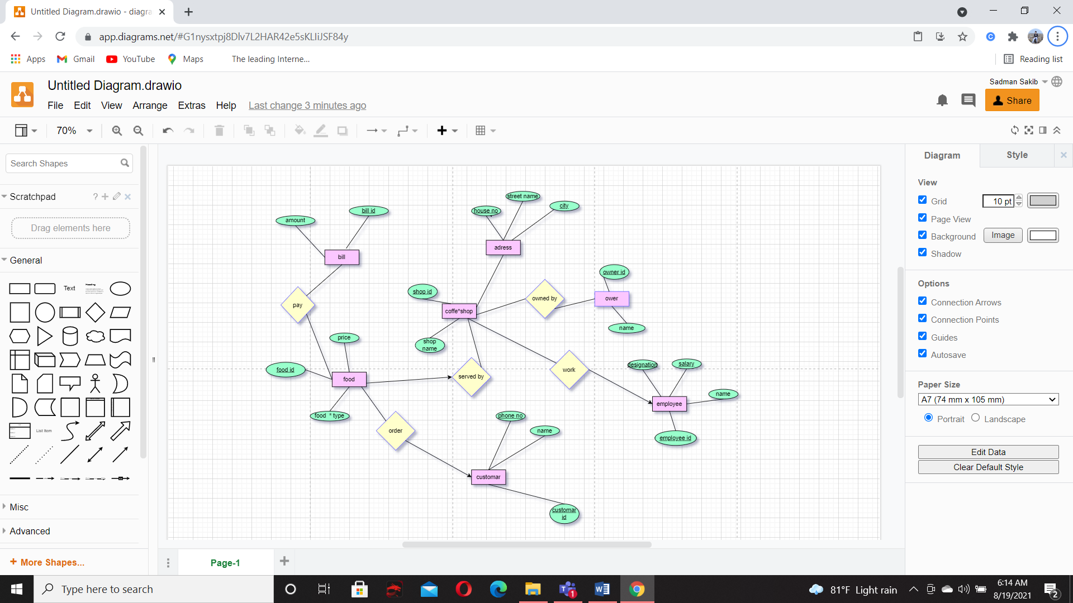

**Normalization:**

**Served by**

**UNF**

Served by (customer_ id, customer_ name, phone no, shop_ id, shop_ name, house_ no, street_ name, city)

**1NF**

phone no is a multi-value attribute

1. customer_ id, customer_ name, phone no, shop_ id, shop_ name, house_ no, street_ name, city

**2NF**

1. customer_ id, customer_ name, phone no

2. shop_ id, shop_ name, house_ no, street_ name, city

**3NF**

**There is no transitive dependency. Relation is already in 3NF**

1. customer_ id, customer_ name, phone no

2. shop_ id, shop_ name, house_ no, street_ name, city

**Table Creation**

1. customer_ id, customer_ name, phone no, **shop_ id**

2. shop_ id, shop_ name, house_ no, street_ name, city

**Order**

**UNF**

Order (food_ id, food_ type, price, customer_ id, customer_ name, phone no)

**1NF**

phone no is a multi-value attribute

1. Food_ id, food_ type, price, customer_ id, customer_ name, phone no

**2NF**

1. food_ id, food_ type, price

2. customer_ id, customer_ name, phone no

**3NF**

There is no transitive dependency. Relation is already in 3NF

1. food_ id, food_ type, price

2. customer_ id, customer_ name, phone no

**Table Creation**

1. food_ id, food_ type, price

2. customer_ id, customer_ name, phone no

3. **food_ id, customer_ id**

**Pay**

**UNF**

Pay (bill_ id, amount, customer_ id, customer_ name, phone no)

**1NF**

phone no is a multi-value attribute

bill_ id, amount, customer_ id, customer_ name, phone no

**2NF**

1. bill_ id, amount

2. customer_ id, customer_ name, phone no

**3NF**

There is no transitive dependency. Relation is already in 3NF

1. bill_ id, amount

2. customer_ id, customer_ name, phone no

**Table Creation**

1. bill_ id, amount

2. customer_ id, customer_ name, phone no

**3. bill_ id, customer_ id**

**work**

**UNF**

work (shop_ id, shop_ name, house_ no, street_ name, city, employee_ id, employee_ name, salary, designation)

**1NF**

There is no multi valued attribute.

1. shop_ id, shop_ name, house_ no, street_ name, city, employee_ id, employee_ name, salary, designation

**2NF**

1. shop_ id, shop_ name, house_ no, street_ name, city

2. employee_ id, employee_ name, salary, designation

**3NF**

There is no transitive dependency. The Relation is already in 3NF.

1. shop_ id, shop_ name, house_ no, street_ name, city

2. employee _id, employee_ name, salary, designation

**TABLE CREATION**

1. shop_ id, shop_ name, house_ no, street_ name, city

**2.** employee_ id, employee_ name, salary, designation, **shop_ id**

**Owned by**

**UNF**

Owned by (shop_ id, shop_ name, house_ no, street_ name, city, owner_ id, owner_ name)

**1NF**

There is no multi valued attribute.

1. shop_ id, shop_ name, house_ no, street_ name, city, owner_ id, owner_ name

**2NF**

1. shop_ id, shop_ name, house_ no, street_ name, city

**2.** owner_ id, owner_ name

**3NF**

There is no transitive dependency. The Relation is already in 3NF.

1. shop_ id, shop_ name, house_ no, street_ name, city

2. owner_ id, owner_ name

**TABLE CREATION**

1. shop_ id, shop_ name, house_ no, street_ name, city

**2.** owner_ id, owner_ name, **shop_ id**

**Temporally Table**

1. customer_ id, customer_ name, phone no, **shop_ id**

2. shop_ id, shop_ name, house_ no, street_ name, city

3. food_ id, food_ type, price

4. customer_ id, customer_ name, phone no

**5. food_ id, customer_ id**

6. bill_ id, amount

7. customer_ id, customer_ name, phone no

**8. bill_ id, customer_ id**

9. shop_ id, shop_ name, house_ no, street_ name, city

10. employee_ id, employee_ name, salary, designation, **shop_ id**

11. shop_ id, shop_ name, house_ no, street_ name, city

12. owner_ id, owner_ name, **shop_ id**

**Final Table**

1. customer_ id, customer_ name, phone no1, phone no2, phone no3, ……... phone no n **shop_ id**

2. shop_ id, shop_ name, house_ no, street_ name, city

3. food_ id, food_ type, price

**4. food_ id, customer_ id**

5. bill_ id, amount

**6. bill_ id, customer_ id**

7. employee_ id, employee_ name, salary, designation, **shop_ id**

8. owner_ id, owner_ name, **shop_ id**

1: Shop Table

create table shop(

shop_id number,

shop_name varchar2(50) not null,

house_no varchar2(50) not null,

street_name varchar2(40) not null,

city varchar2(40)

)

alter table shop add constraint ab primary key(shop_id)

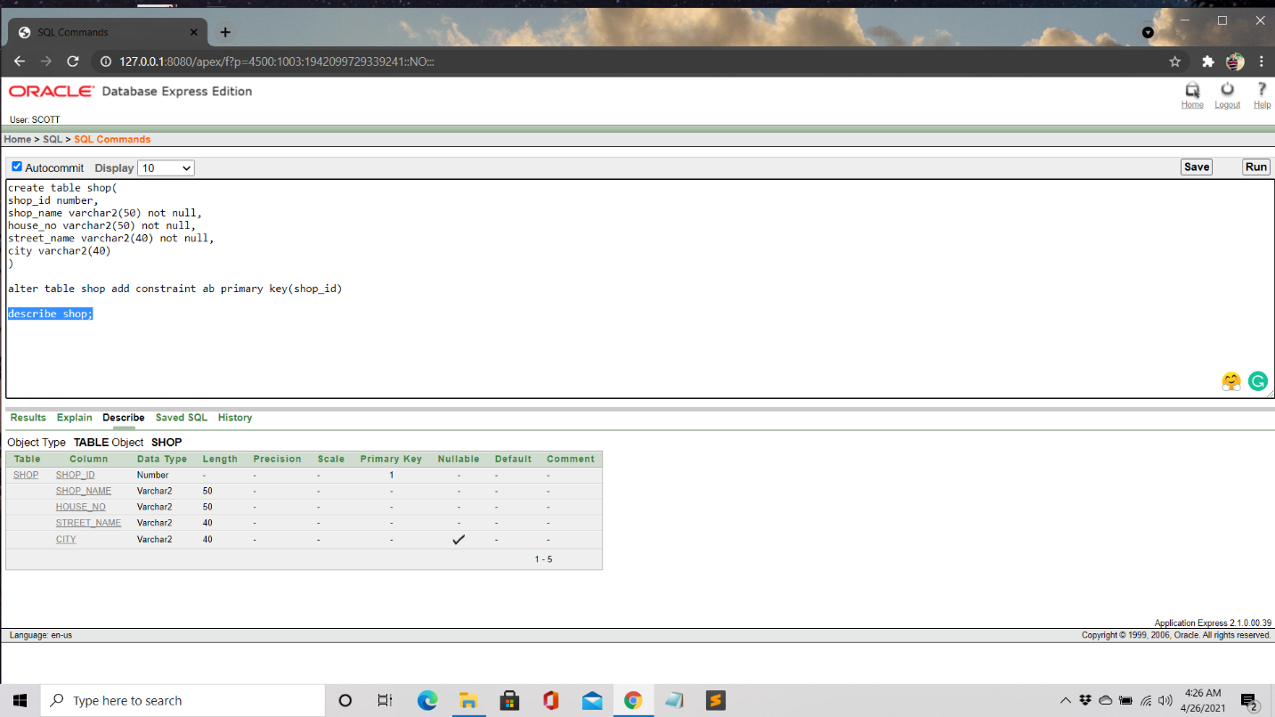

Data Insertion for Shop Table **:**

insert into shop (shop_id,shop_name ,house_no,street_name,city)

values (shop_id_seq.NEXTVAL,'Star Black','26/A','300 feet','Dhaka');

insert into shop (shop_id,shop_name ,house_no,street_name,city)

values (shop_id_seq.NEXTVAL,'creme de la creme','66/A','Gulshan-2','Dhaka');

insert into shop (shop_id,shop_name ,house_no,street_name,city)

values (shop_id_seq.NEXTVAL,'Coffee shot','32/B','Boddar Haat','Chittagong');

insert into shop (shop_id,shop_name ,house_no,street_name,city)

values (shop_id_seq.NEXTVAL,'Chalk & beans','134','Cantonment Rd','Rajshahi');

insert into shop (shop_id,shop_name ,house_no,street_name,city)

values (shop_id_seq.NEXTVAL,'Manik cafe','25','Sariakandi Rd','Bogura');

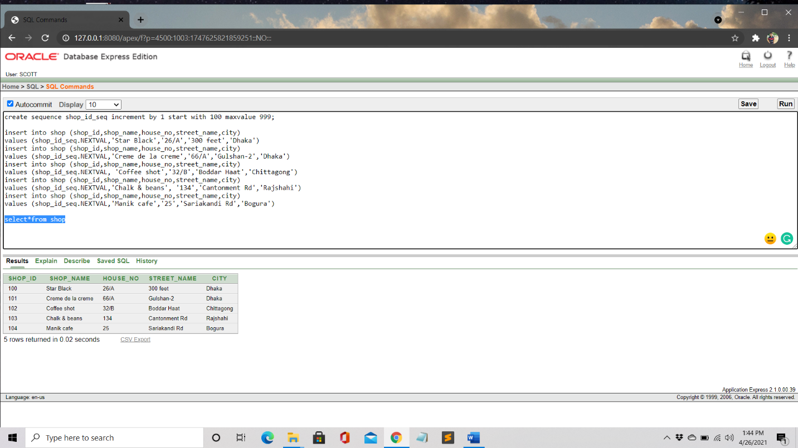

2: Customer Table

create table customer (

customer_id number(3),

customer_name varchar2(50) not null,

phone_no1 number(15) not null,

phone_no2 number(15) not null,

shop_id number(3) not null

)

alter table customer add constraint ac primary key(customer_id)

alter table customer add constraint ad foreign key(shop_id) references shop(shop_id)

desc customer;

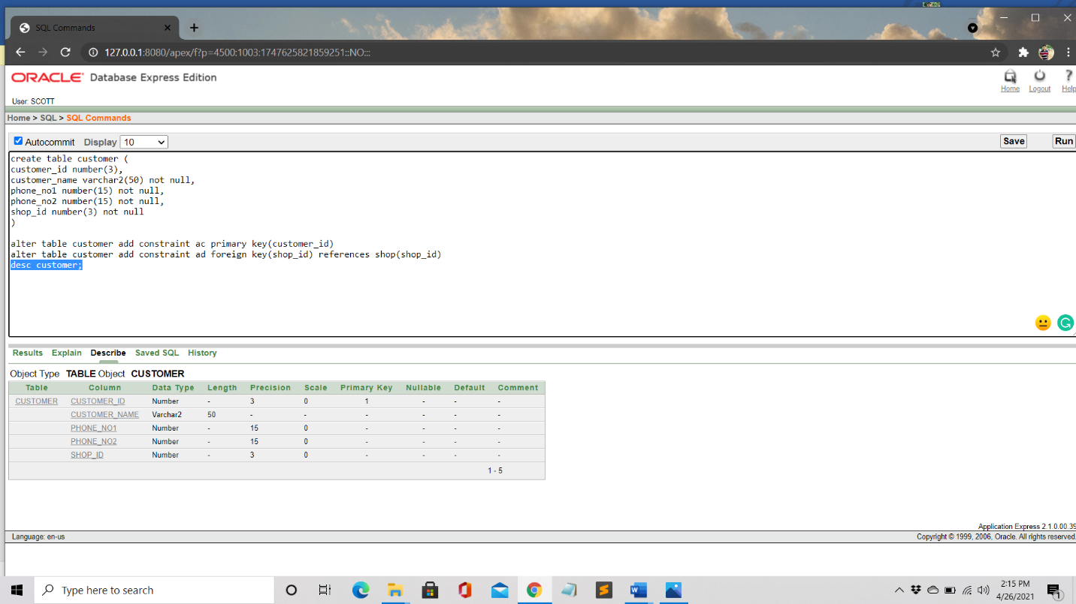

Data Insertion for Customer Table:

insert into customer(customer_id, customer_name,phone_no1,phone_no2,shop_id)

values(customer_id_seq.NEXTVAL,'Rafi','01736673545','01917275243','100')

insert into customer(customer_id,customer_name,phone_no1,phone_no2,shop_id)

values(customer_id_seq.NEXTVAL,'Xahidul','01576238313','01962378122','101')

insert into customer(customer_id,customer_name,phone_no1,phone_no2,shop_id)

values(customer_id_seq.NEXTVAL,'Afif','01817234232','01673247232','102')

insert into customer(customer_id,customer_name,phone_no1,phone_no2,shop_id)

values(customer_id_seq.NEXTVAL,'Ahsanul','01673842312','01916804323','103')

insert into customer(customer_id,customer_name,phone_no1,phone_no2,shop_id)

values(customer_id_seq.NEXTVAL,'Roktim','01910345266','01717236426','104')

select* from customer

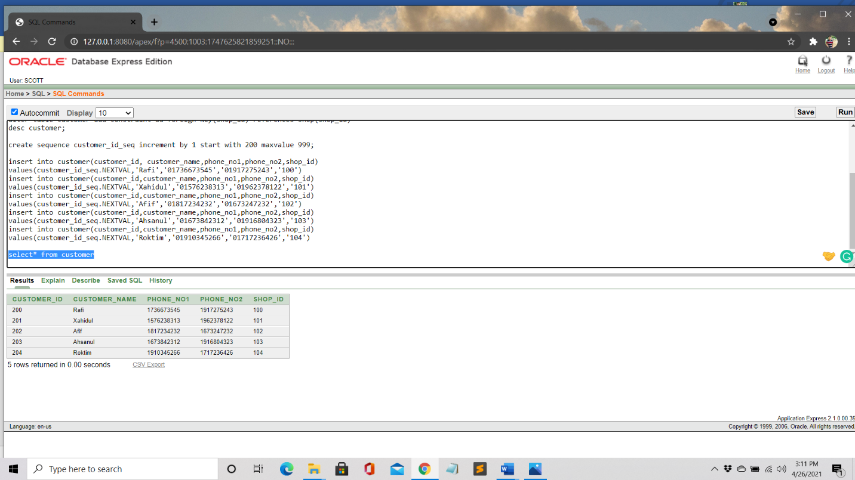

3: Employee Table

create table employee (

employee_id number (3),

employee_name varchar2(50) not null,

salary number(20) not null,

designation varchar2(40) not null,

shop_id number(3) not null

)

alter table employee add constraint dc primary key(employee_id)

alter table employee add constraint ds foreign key(shop_id) references shop(shop_id)

desc employee;

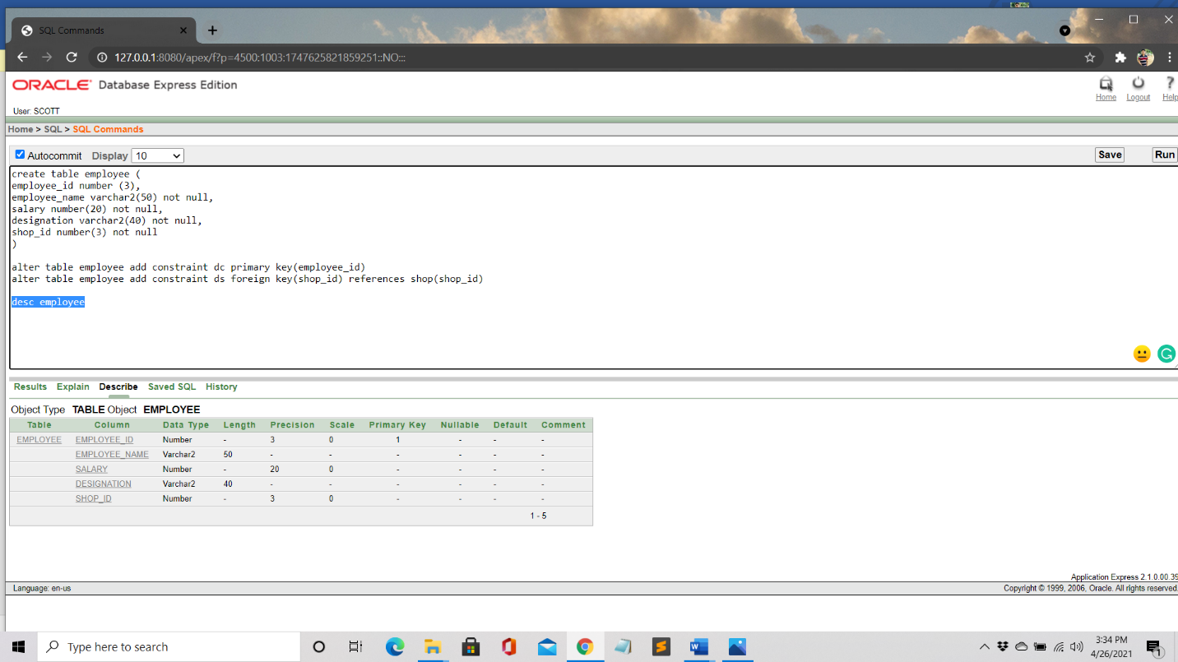

Data Insertion for Employee Table:

insert into employee (employee_id, employee_name, salary, designation, shop_id)

values (employee_id_seq.NEXTVAL, 'FARID', '10000', 'MANAGER', '100')

insert into employee (employee_id, employee_name, salary, designation, shop_id)

values (employee_id_seq.NEXTVAL, 'RANA', '6000', 'CHEF', '100')

insert into employee (employee_id, employee_name, salary, designation, shop_id)

values (employee_id_seq. NEXTVAL, 'RAJU', '5000', 'WAITER', '100')

insert into employee (employee_id, employee_name, salary, designation, shop_id)

values (employee_id_seq. NEXTVAL, 'NIPA', '5000', 'MANAGER', '100')

insert into employee (employee_id, employee_name, salary, designation, shop_id)

values (employee_id_seq. NEXTVAL, 'SAAD', '10000', 'MANAGER', '101')

insert into employee (employee_id, employee_name, salary, designation, shop_id)

values (employee_id_seq .NEXTVAL, 'KAMRUL', '6000', 'CHEF', '101')

insert into employee (employee_id, employee_name, salary, designation, shop_id)

values (employee_id_seq.NEXTVAL, 'MAFI','5000','WAITER','101')

insert into employee (employee_id, employee_name, salary, designation, shop_id)

values (employee_id_seq.NEXTVAL,'MOU','5000','WAITER','101')

insert into employee (employee_id, employee_name, salary, designation, shop_id)

values (employee_id_seq.NEXTVAL,'RONJU','10000','MANAGER','102')

insert into employee (employee_id, employee_name, salary, designation, shop_id)

values (employee_id_seq.NEXTVAL,'TOUHID','6000','CHEF','102')

insert into employee (employee_id, employee_name, salary, designation, shop_id)

values (employee_id_seq.NEXTVAL,'SHAFI','5000','WAITER','102')

insert into employee (employee_id, employee_name, salary, designation, shop_id)

values (employee_id_seq.NEXTVAL,'SHITHI',5000,'WAITER','102')

insert into employee (employee_id, employee_name, salary, designation, shop_id)

values (employee_id_seq.NEXTVAL,'RONY','10000','MANAGER','103')

insert into employee (employee_id, employee_name, salary, designation, shop_id)

values (employee_id_seq. NEXTVAL,'SIAM','6000','CHEF','103')

insert into employee (employee_id, employee_name, salary, designation, shop_id)

values (employee_id_seq. NEXTVAL,'ANGON','5000','WAITER','103')

insert into employee (employee_id, employee_name, salary, designation, shop_id)

values (employee_id_seq. NEXTVAL,'LAMIYA','5000','WAITER','103')

insert into employee (employee_id, employee_name, salary, designation, shop_id)

values (employee_id_seq. NEXTVAL,'SAHIL','10000','MANAGER','104')

insert into employee (employee_id, employee_name, salary, designation, shop_id)

values (employee_id_seq. NEXTVAL,'ROBIN','6000','CHEF','104')

insert into employee (employee_id, employee_name, salary, designation, shop_id)

values (employee_id_seq. NEXTVAL,'TURJO','5000','WAITER','104')

insert into employee (employee_id, employee_name, salary, designation, shop_id)

values (employee_id_seq. NEXTVAL,'NILA','5000','WAITER','104')

select* from employee

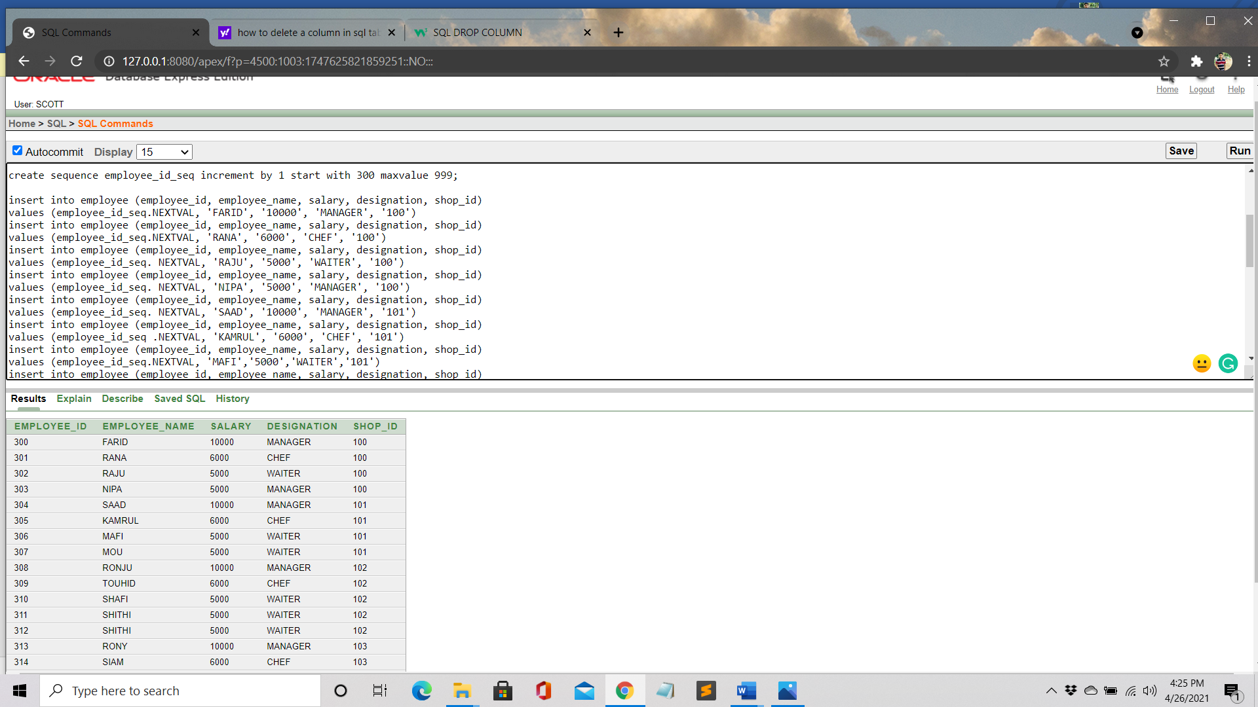

4: Owner Table

create table owner (

owner_id number (3),

owner_name varchar2(50) not null,

shop_id number(3) not null

)

alter table owner add constraint qw primary key(owner_id)

alter table owner add constraint er foreign key(shop_id) references shop(shop_id)

desc owner;

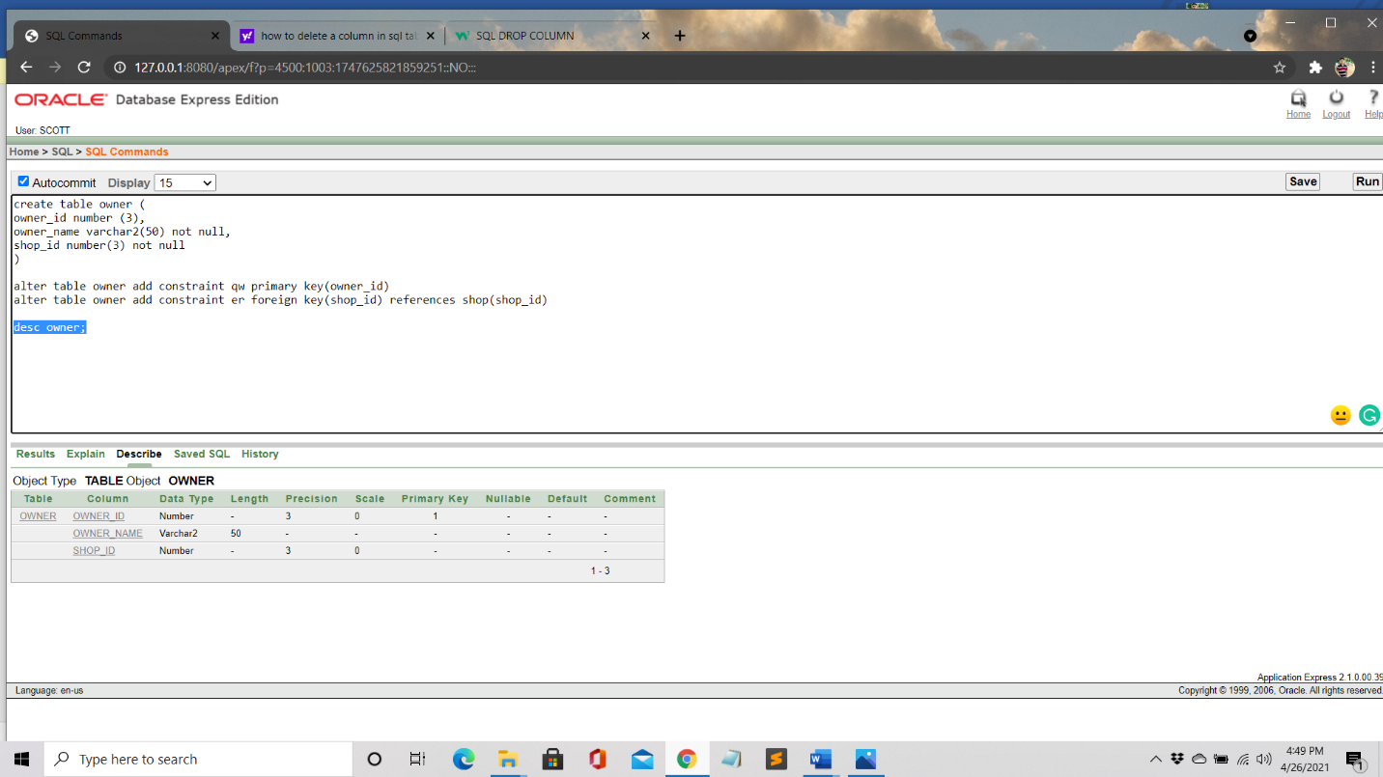

Date Insertion for Owner Table:

insert into owner (owner_id, owner_name, shop_id)

values (owner_id_seq.NEXTVAL, 'HIMEL',100)

insert into owner (owner_id, owner_name, shop_id)

values (owner_id_seq.NEXTVAL, 'SHITHIL',101)

insert into owner (owner_id, owner_name, shop_id)

values (owner_id_seq.NEXTVAL, 'IMRAN',102)

insert into owner (owner_id, owner_name, shop_id)

values (owner_id_seq.NEXTVAL, 'FAHIM',103)

insert into owner (owner_id, owner_name, shop_id)

values (owner_id_seq.NEXTVAL, 'DOYA',104)

select* from owner;

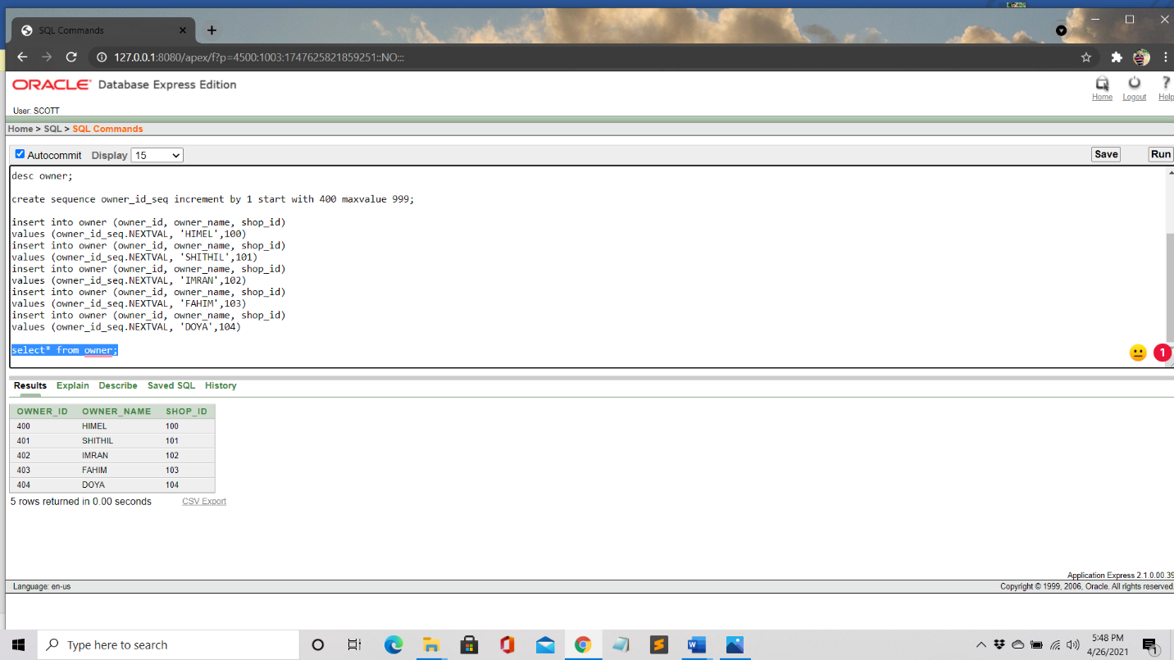

5: Bill Table

create table bill (

bill_id number (3),

amount varchar2(50) not null

)

alter table bill add constraint zx primary key(bill_id)

desc bill;

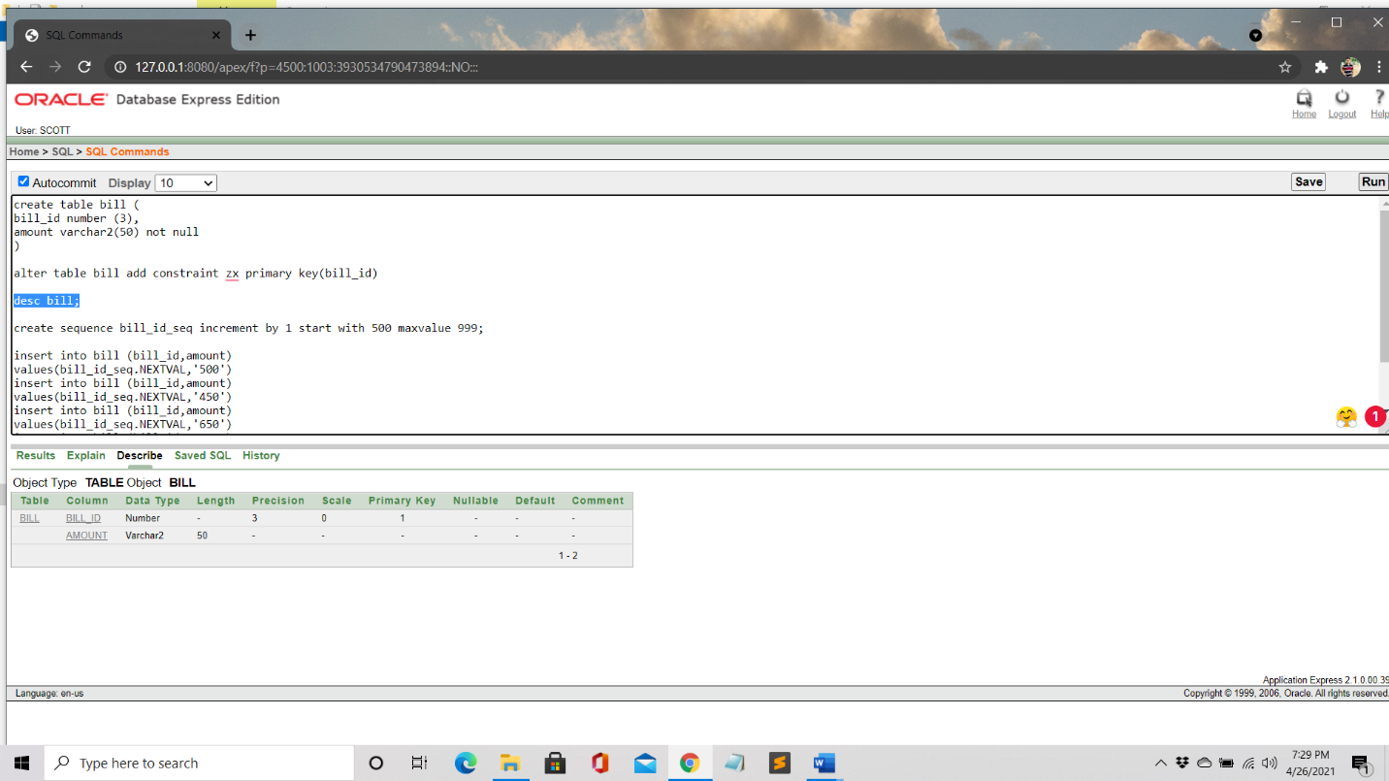

Data Insertion for Bill Table:

insert into bill (bill_id,amount)

values(bill_id_seq.NEXTVAL,'500')

insert into bill (bill_id,amount)

values(bill_id_seq.NEXTVAL,'450')

insert into bill (bill_id,amount)

values(bill_id_seq.NEXTVAL,'650')

insert into bill (bill_id,amount)

values(bill_id_seq.NEXTVAL,'300')

insert into bill (bill_id,amount)

values(bill_id_seq.NEXTVAL,'120')

select* from bill;

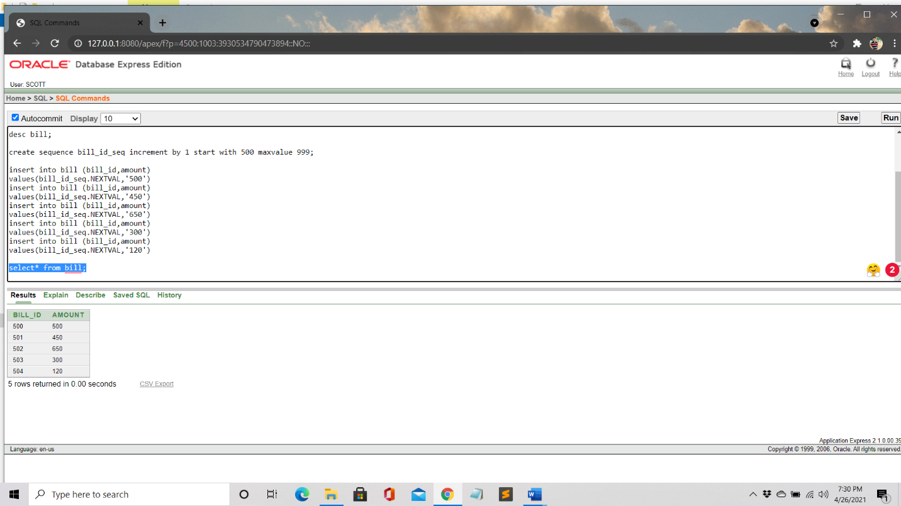

6: Food Table:

create table food (

food_id number (3),

food_type varchar2(50) unique,

price varchar2(50) not null

)

alter table food add constraint jg primary key(food_id)

desc food;

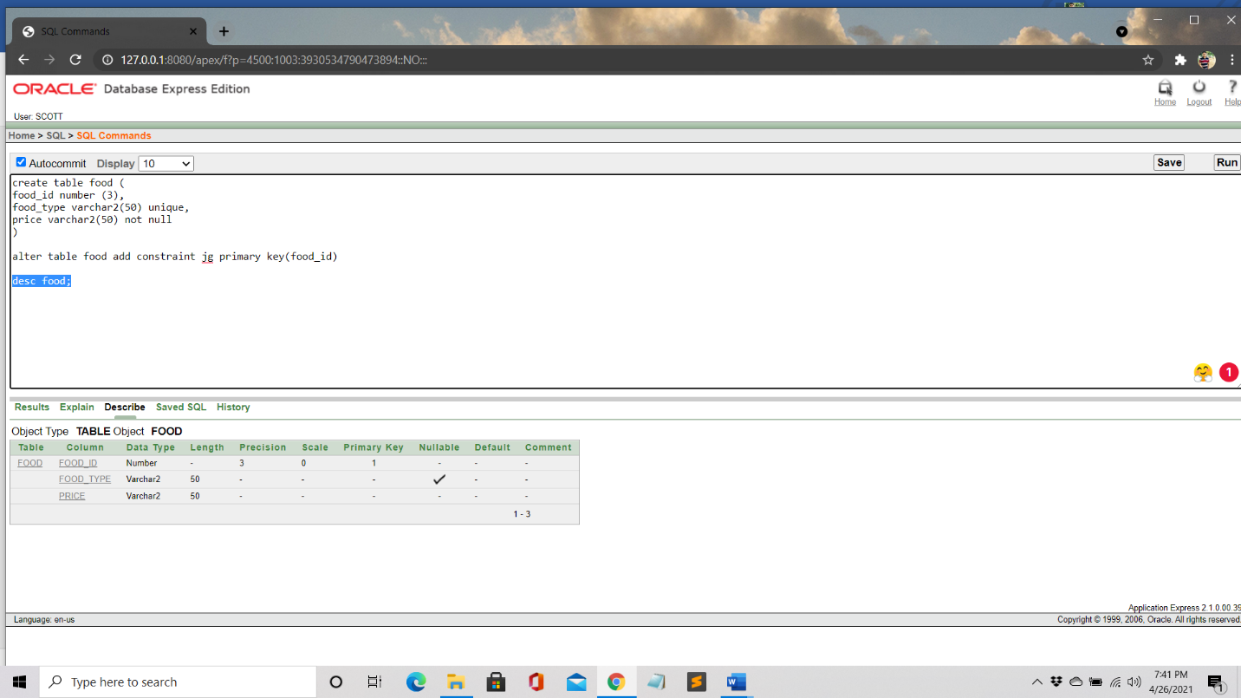

Data insertion for Food Table:

insert into food (food_id, food_type, price)

values (food_id_seq.NEXTVAL, 'PASTRY', '300')

insert into food (food_id,food_type,price)

values (food_id_seq.NEXTVAL, 'SPECIAL LACCHI','350')

insert into food (food_id, food_type, price)

values (food_id_seq.NEXTVAL, 'COLD COFFEE', '150')

insert into food (food_id, food_type, price)

values (food_id_seq.NEXTVAL, 'RASMALAI CAKE', '550')

insert into food (food_id,food_type, price)

values (food_id_seq.NEXTVAL, 'COOKIES', '200')

insert into food (food_id, food_type, price)

values (food_id_seq.NEXTVAL, 'SANDWICH', '80')

insert into food (food_id, food_type, price)

values (food_id_seq.NEXTVAL, 'CAPPUCCINO', '120')

select * from food;

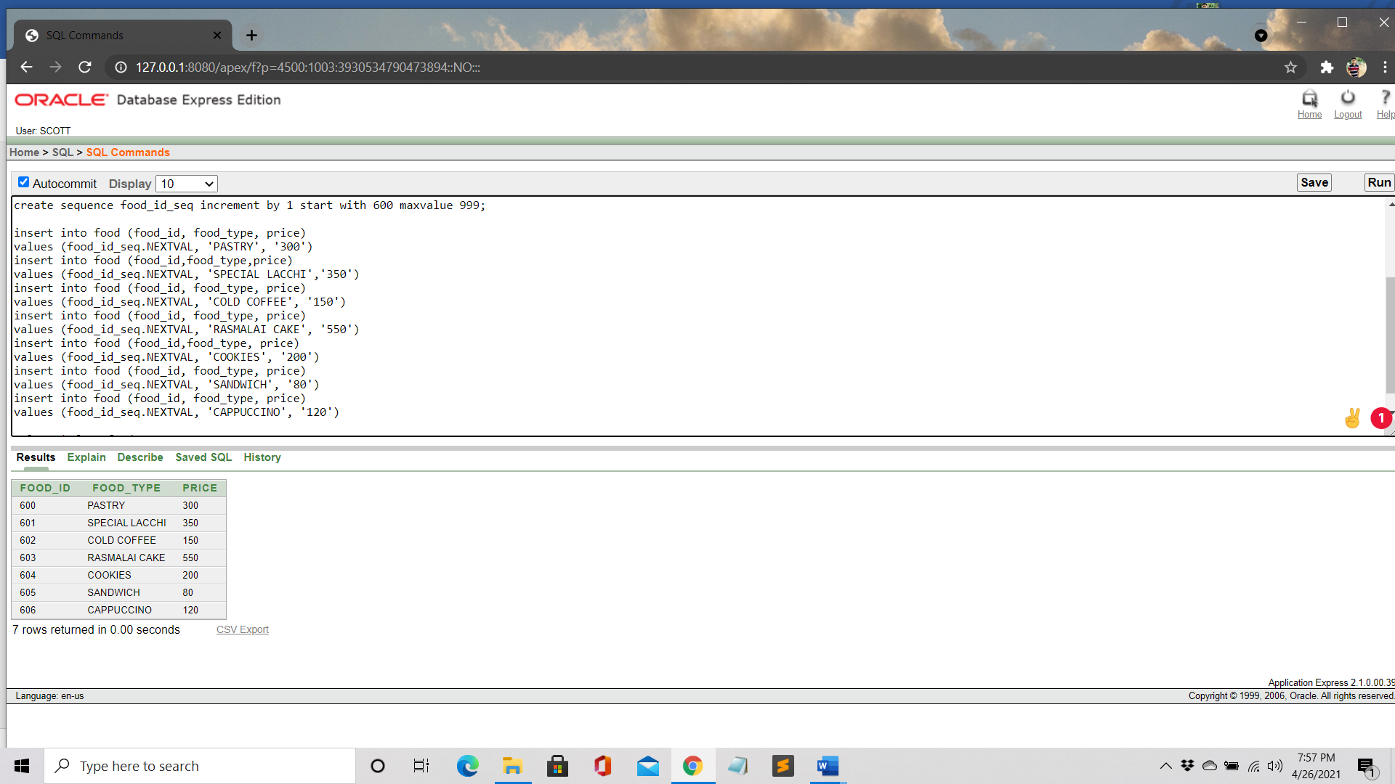

7: Food and Customer Table:

Create table food_and_customer_table(

food_id number(3)not null,

customer_id number(3) not null

)

alter table food_and_customer_table add constraint bn primary key(food_id,customer_id)

alter table food_and_customer_table add constraint bnp foreign key(food_id) references food(food_id)

alter table food_and_customer_table add constraint bp foreign key(customer_id) references customer(customer_id)

desc food_and_customer_table;

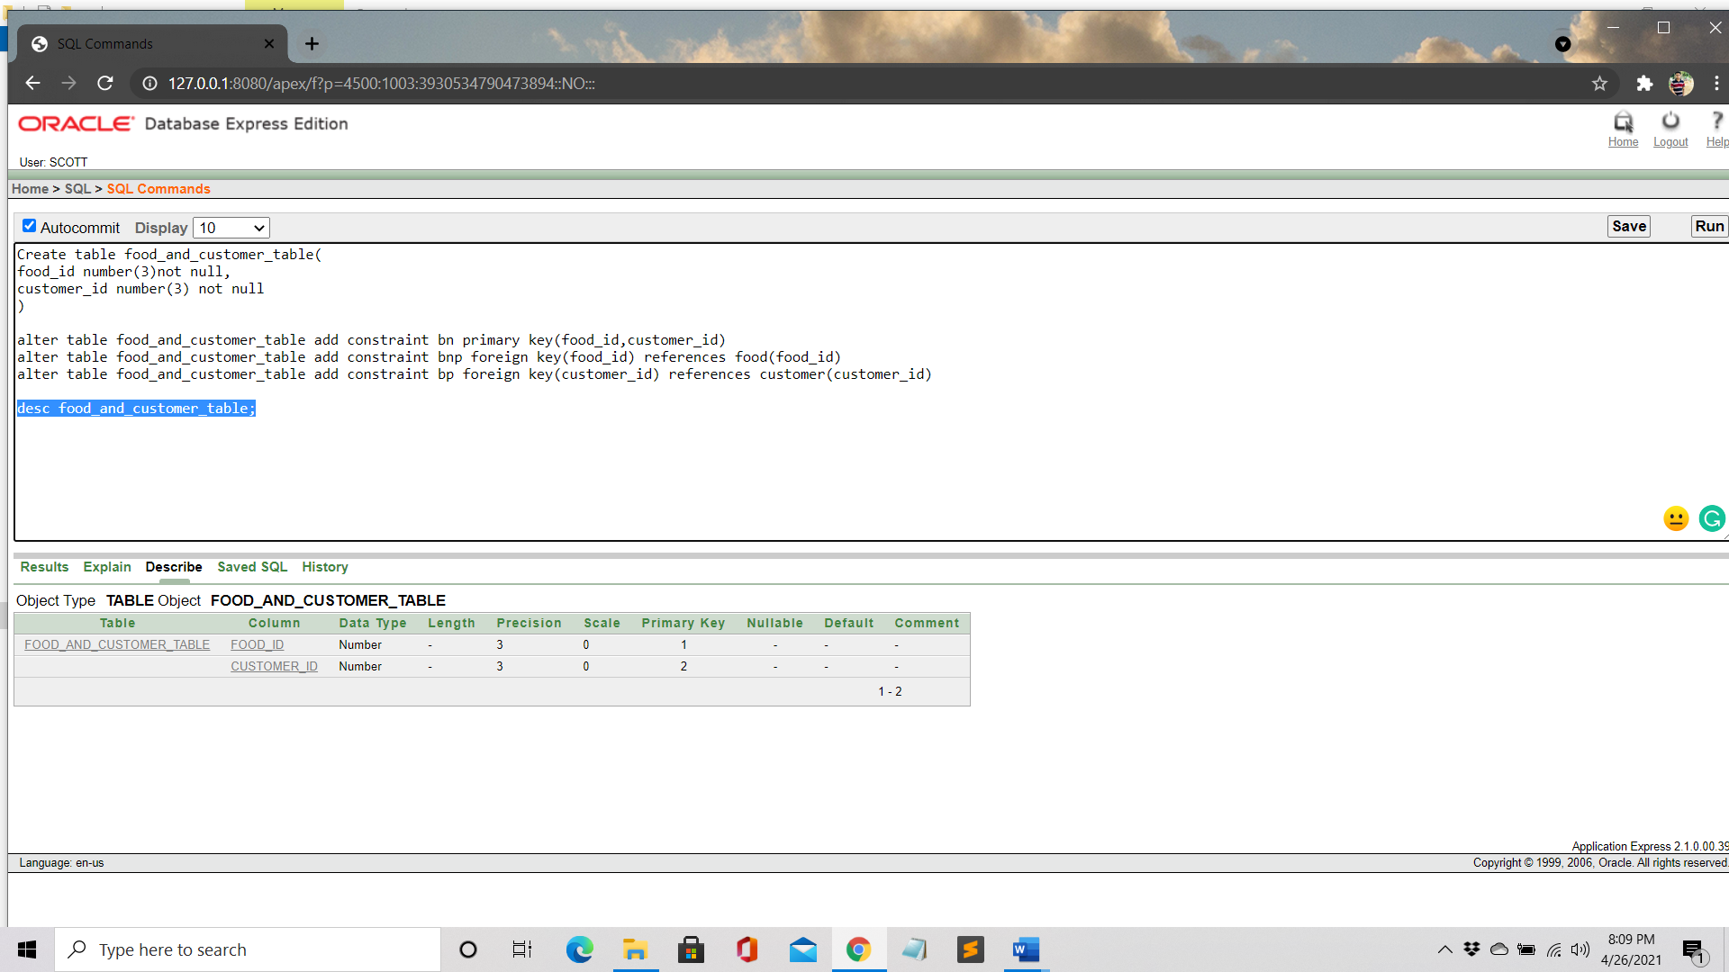

Data Insertion for Food and Customer Table:

insert into food_and_customer_table(food_id ,customer_id)

values('600','201')

insert into food_and_customer_table(food_id ,customer_id)

values('604','204')

insert into food_and_customer_table(food_id ,customer_id)

values('602','201')

insert into food_and_customer_table(food_id ,customer_id)

values('605','204')

insert into food_and_customer_table(food_id ,customer_id)

values('601','203')

insert into food_and_customer_table(food_id ,customer_id)

values('606','200')

insert into food_and_customer_table(food_id ,customer_id)

values('604','202')

select* from food_and_customer_table;

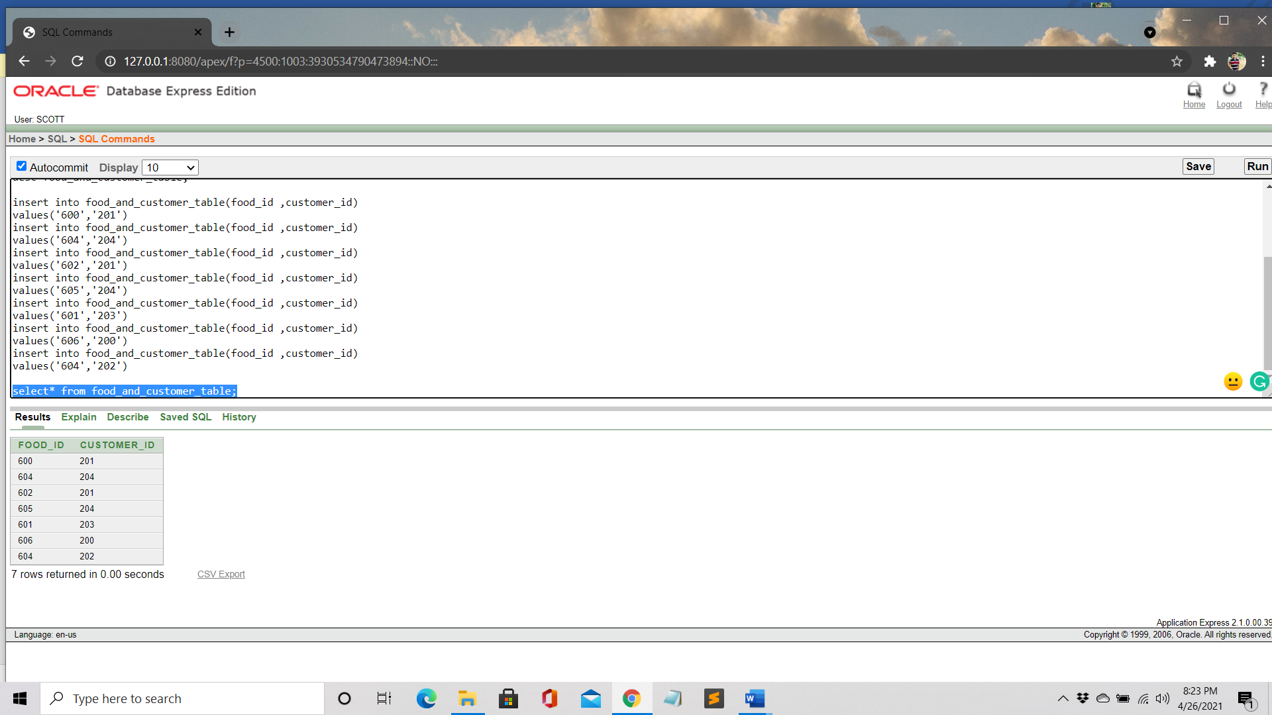

8: Bill and Customer Table:

create table bill_and_customer_table(

bill_id number(3) not null,

customer_id number(3) not null

)

alter table bill_and_customer_table add constraint bn1 primary key(bill_id,customer_id)

alter table bill_and_customer_table add constraint bnp1 foreign key(bill_id) references bill(bill_id)

alter table bill_and_customer_table add constraint bp1 foreign key(customer_id) references customer(customer_id)

desc bill_and_customer_table;

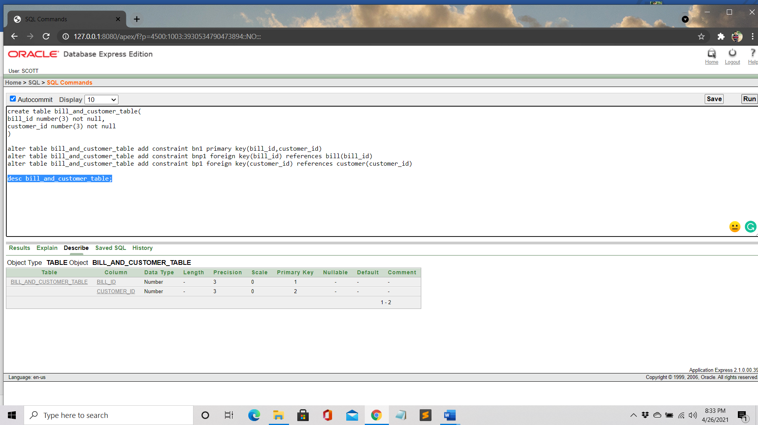

Data Insertion for Bill and Customer Table:

insert into bill_and_customer_table(bill_id ,customer_id)

values('500','201')

insert into bill_and_customer_table(bill_id ,customer_id)

values('501','204')

insert into bill_and_customer_table(bill_id ,customer_id)

values('503','202')

insert into bill_and_customer_table(bill_id ,customer_id)

values('504','203')

insert into bill_and_customer_table(bill_id ,customer_id)

values('502','200')

select* from bill_and_customer_table;

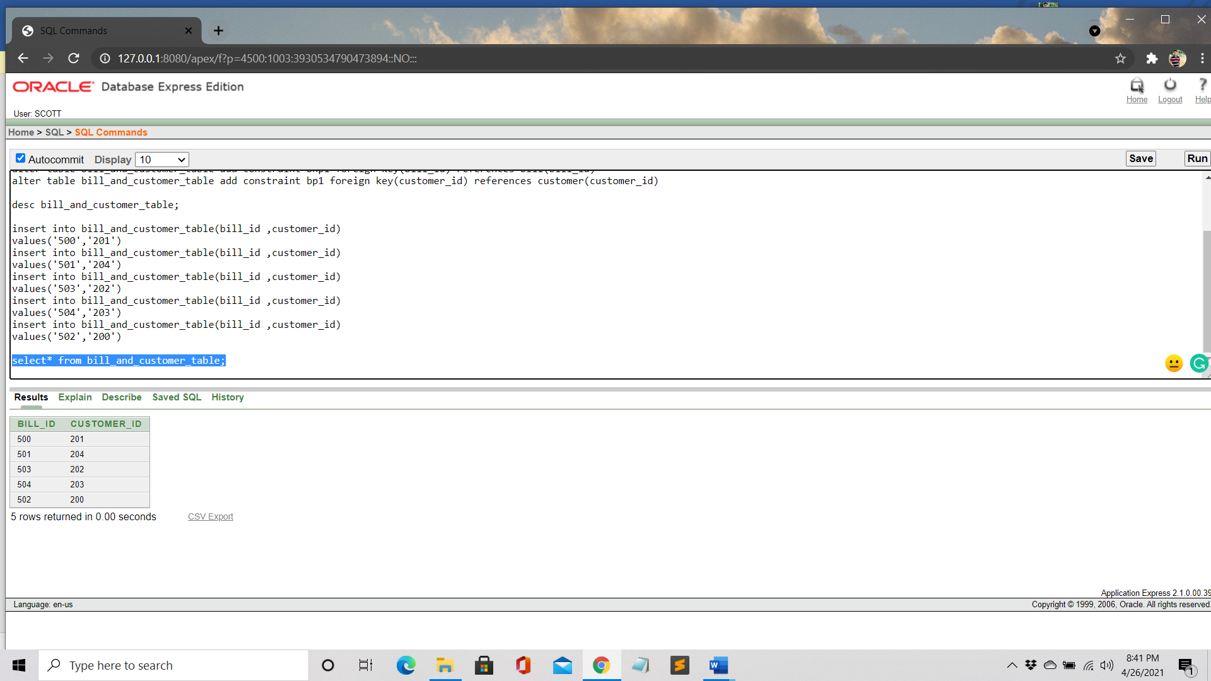

Joining :

**Equijoin**

1. select customer_id ,Food.FOOD_ID,FOOD_TYPE,PRICE

FROM Food ,food_and_customer_table

WHERE Food.food_id=food_and_customer_table.food_id;

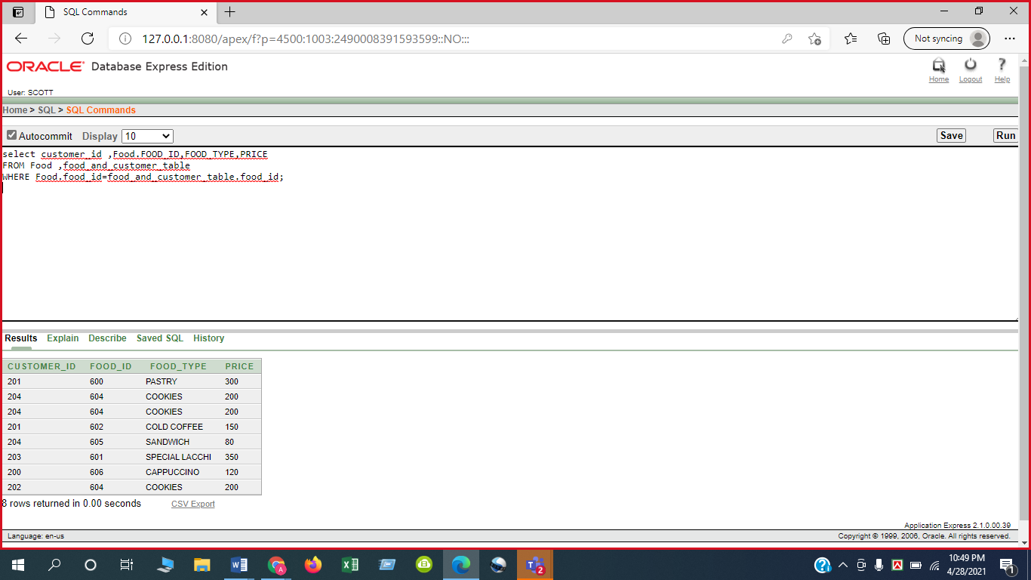

2 .

SELECT bill_id, bill_and_customer_table.customer_id,customer_name,phone_no1,

phone_no2,shop_id

FROM bill_and_customer_table,customer

WHERE bill_and_customer_table.customer_id=customer.customer_id;

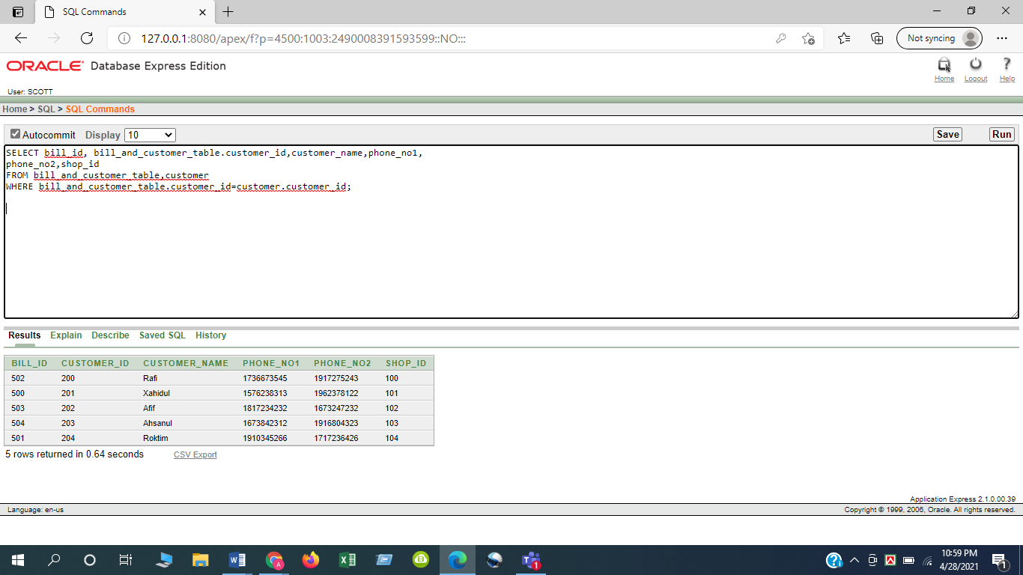

**Outer join :**

SELECT BILL_ID,a.customer_id,CUSTOMER_NAME,PHONE_NO1,PHONE_NO2,SHOP_ID

FROM bill_and_customer_table a,customer c

WHERE a.customer_id =c.customer_id(+);

**Self – Join :**

SELECT *

FROM EMPLOYEE e,EMPLOYEE f

WHERE e.employee_id =f.employee_id;

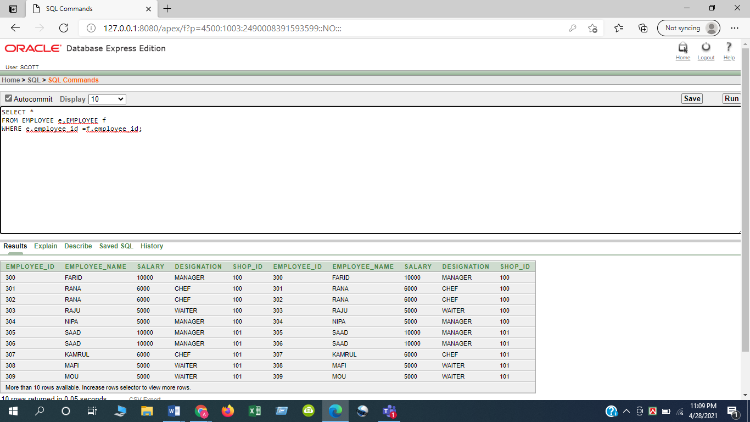

**Subquery:**

1: SELECT MAX (SALARY) AS "SECOND MAX SALARY"

FROM EMPLOYEE

WHERE SALARY < ( SELECT MAX (SALARY)

FROM EMPLOYEE)

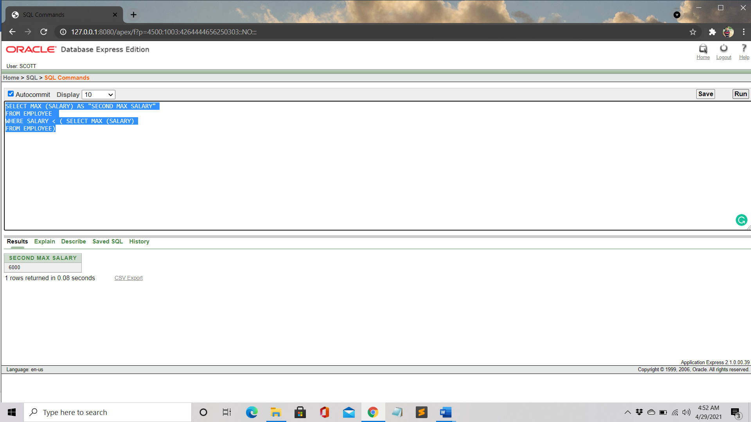

2: SELECT *

FROM EMPLOYEE

WHERE shop_id IN (SELECT shop_id

FROM shop

WHERE SHOP_NAME='Star Black');

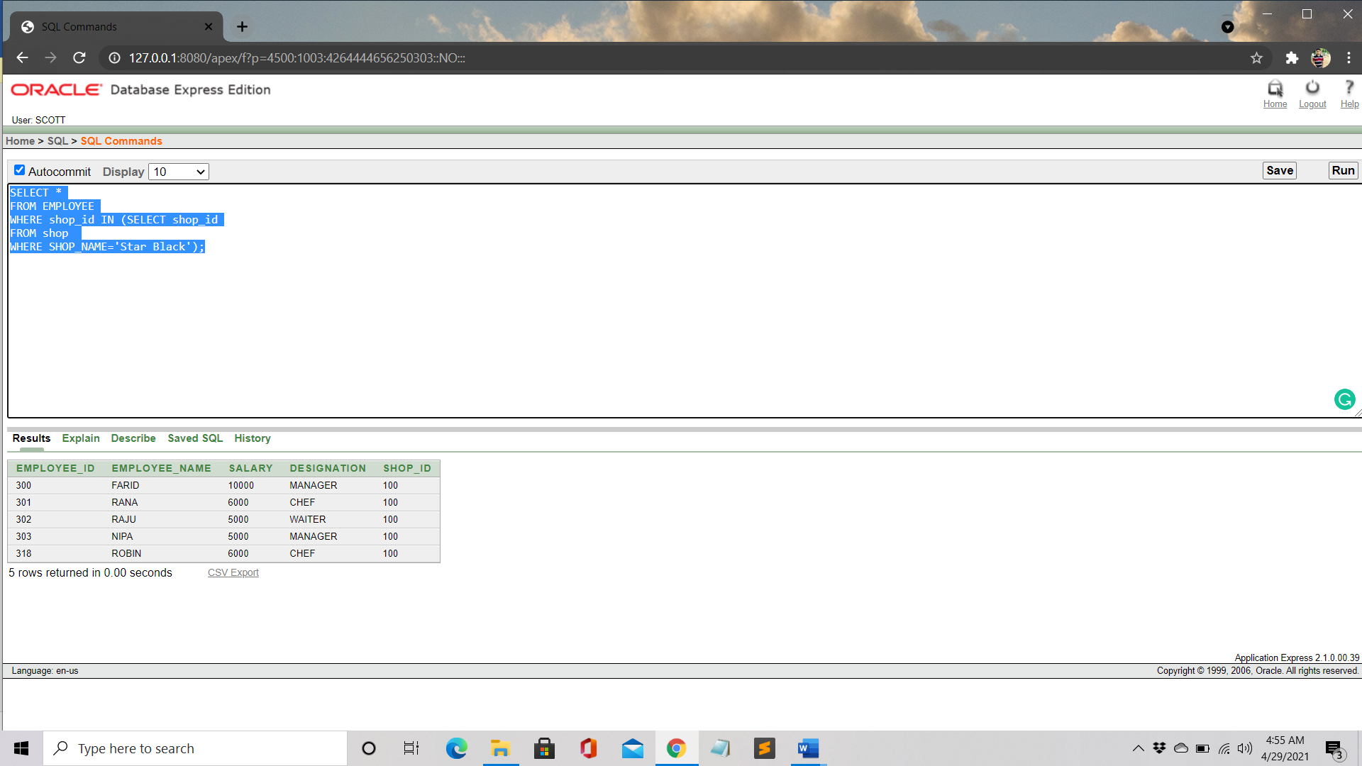

**Conclusion :**

Our project deals with Coffee Shop Management System. We developed Coffee Shop Management system to maintain orders and management of a coffee shop. With selecting Menu Order the system displays the Available items of the list and with this the user can place order with item quantity. Our admin panel is responsible for receiving all processing orders from customers. In our system shop name and address is stored. We also stored employee name, salary, designation and also stored customer name and phone numbers.

At first, we have drawn ER diagram using DIA tool. Then we normalize the diagram for final table. Grant create table, create view and create sequence to accounts. We have created table following our final table which we have get from normalization and insert necessary data into table and also insert screenshot of all of these. Firstly in query writing, we have done sub-query for employee table then we have done joining in customer table and employee table. After that we have assign view in employee table and owner table. We have done query writing by creating some question and by answering them.

In future we will invent an app using java, java script and c#. It will be very helpful for our future business plan. By using the app owners/ users can actuate any update in the system. We can make sure best security for the system.